**ACTIVENET\_SYSTEM\_STRINGS**

* The table is pretty static. It is updated during initialization if there is any change needed and the change would come from code.

**ACTIVITIES**

* Create a new activity

**ACTIVITY\_DATES**

* Create activity dates

**ACTIVITY\_FEES**

* Create activity fees

**ACTIVITY\_RESERVATION\_PATTERN\_DATES**

* Create a Meeting Dates, Times and Location pattern in Activity Details or Activity Dates page.

**ACTIVITY\_RESERVATION\_PATTERNS**

* Create a Meeting Dates, Times and Location pattern in Activity Details or Activity Dates page.

**ACTIVITY\_TYPE\_CONFIGS**

* Create a new Activity Type with some components selected

**ACTIVITY\_TYPES**

* Create a new Activity Type

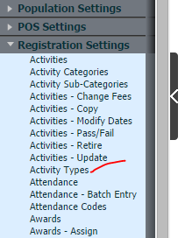

**ACTIVITYATTENDANCE**

* Enroll a customer into an activity. After that is done, go to Front Desk -> Registrations -> Attendance, search for the activity and mark the enrollee as attended.

**ACTIVITYDIVISIONS**

* Create Division under Activity Functions page.

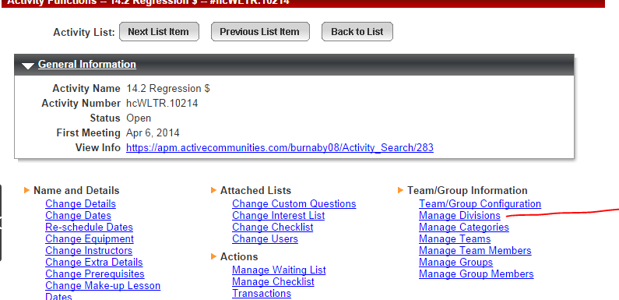

**ACTIVITYREGISTRATIONWINDOWS**

* Set Registration Windows under Activity Detail page
* 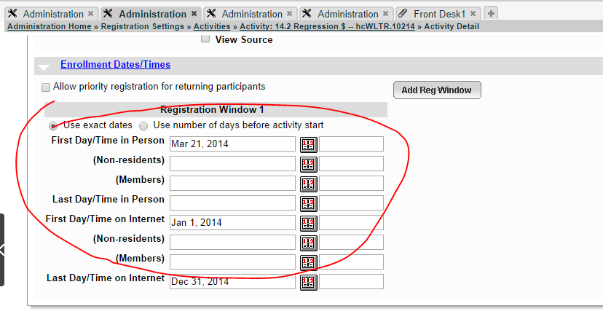

**ACTIVITYSTATISTICS**

* Maintain by system for activity openings.

**AGE\_CATEGORIES**

* Create Birth Date Alternativies
* 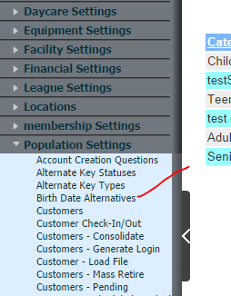

**ALTERNATE\_KEY\_TYPES**

* 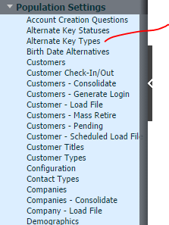

**CENTERS**

* 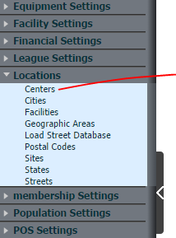

**CHARGES**

* 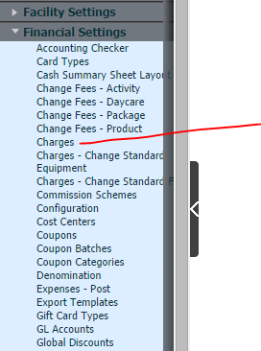

**CLIENT\_MEMBERSHIP\_DATA**

* Sell new memberships will add values into the table

**COMPANIES**

* 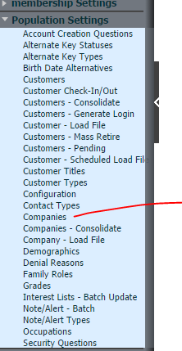

**COMPANY\_TEAMCATEGORIES**

* Administration -> Population Settings -> Companies -> Search for a company -> Manage Team/Group Categories

**CONTACTTYPES**

* Administration -> Population Settings -> Contact Types

**CONV\_FEE\_OPTIONS**

* Setup a processing fees at activity level.
* 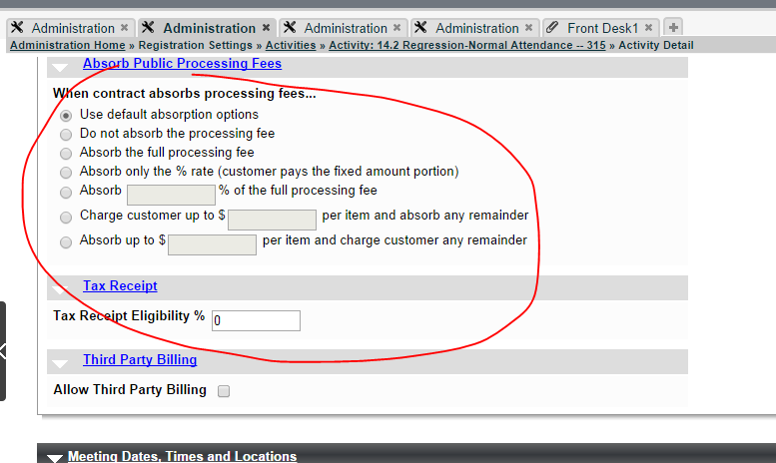

**CUSTOMER\_ALTERNATE\_KEYS**

* Create alternate keys under a customer account
* 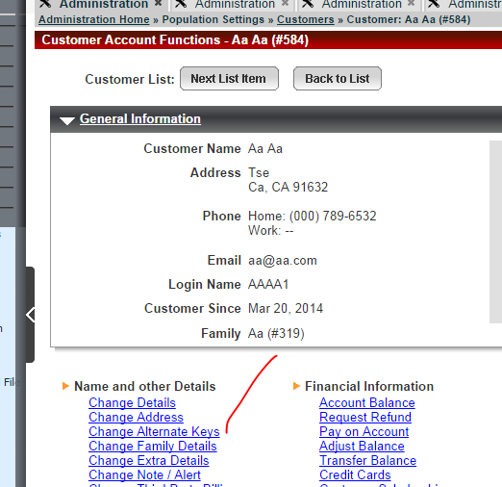

**CUSTOMER\_DEMOGRAPHICS**

* 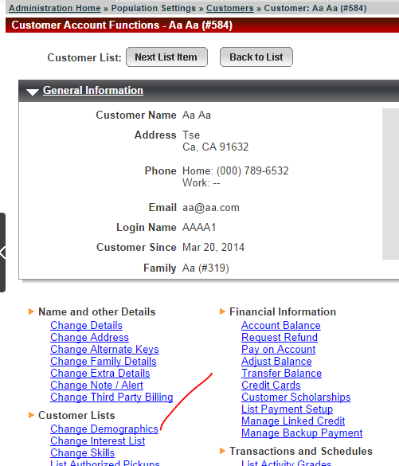

**CUSTOMER\_MEMBERSHIP\_DATES**

* Records are added when selling a membership to a customer

**CUSTOMER\_TITLES**

* 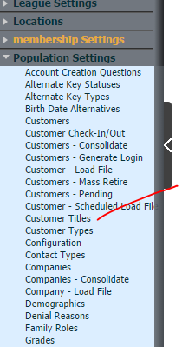

**CUSTOMERS**

* Add a new customer

**CUSTOMERTYPES**

* 

**DCPENDINGREGISTRATIONS**

* Records are created while enrolling a customer into a Daycare program.

**DCPROGRAMS**

* Create a Daycare program
* 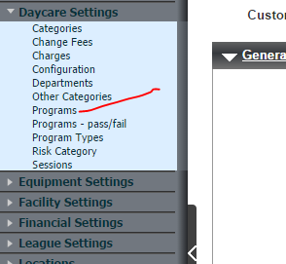

**DCPROGRAMSESSIONS**

* Assign sessions in DC program detail page

**DCREGISTRATIONCHANGES**

* Front desk -> Daycare -> Enroll/Modify enrollment

**DCREGISTRATIONS**

* Front desk -> Daycare -> Enroll/Modify enrollment

**DCSESSIONDATES**

* Create dates under a DC Session
* 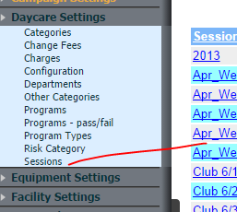

**DCSESSIONS**

* 

**DEMOGRAPHICS**

* 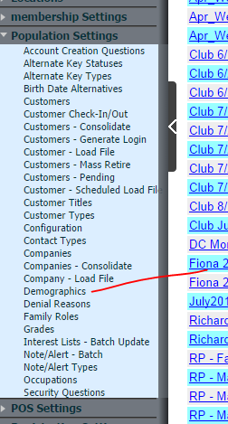

**ENTRY\_POINTS**

* 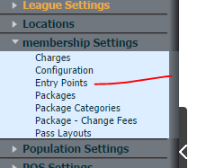

**EVENTTYPE\_FACILITY**

* Administration > Facility Settings > Event Types -🡪 Facilities

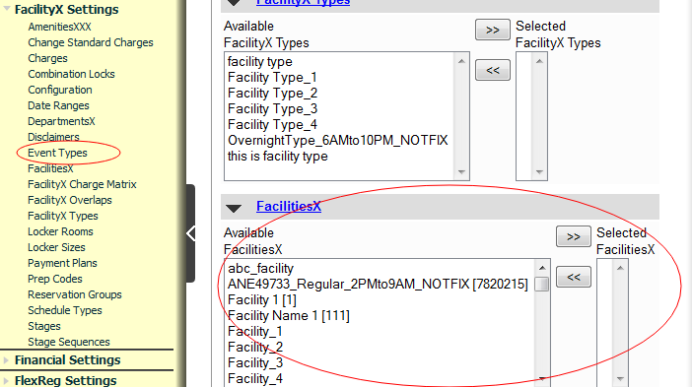

**EVENTTYPE\_FACILITYTYPE**

* Administration > Facility Settings > Event Types -🡪 Facility Types

**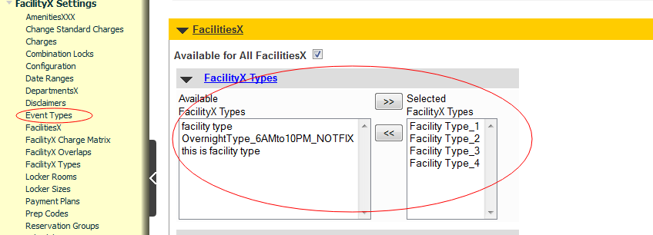**

**EVENTTYPES**

* Administration > Facility Settings > Event Types

**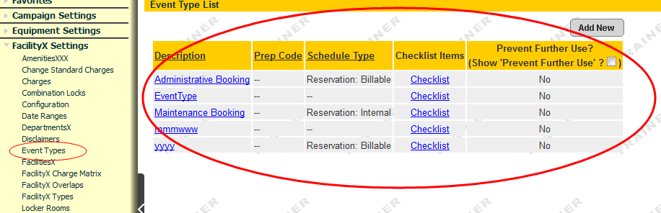**

**FACILITIES**

* Administration > Facility Settings > Facilities

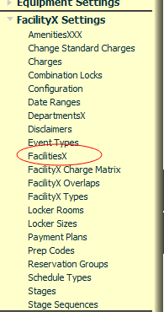

**FACILITY\_CATEGORIES**

* Administration > Equipment Settings 🡪 Equipment Categories

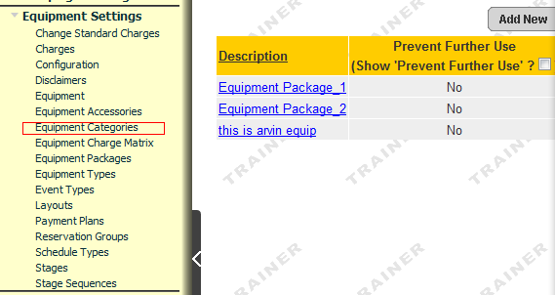

**FACILITY\_SCHEDULES**

* Font Desk > Reserve 🡪 Reserve Facility / Reserve Equipment / Reserve Instructor

Customer Reserve facility/equipment/instructor

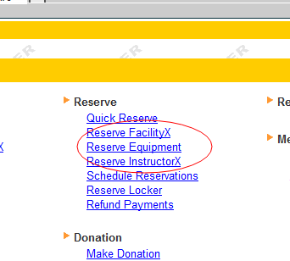

**FACILITYEVENTCAPACITY**

* Modify Facility . Click any facility into “Name and Details” 🡪 Change Facility Event Capacities

When click link “change facility event capacities” this table is accessed.

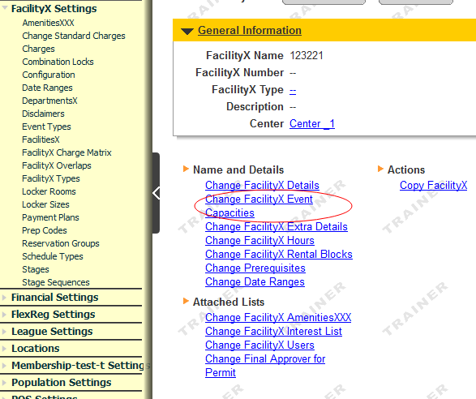

**FACILITYHOURS**

* Create facility hours. Click any facility into “Name and Details” 🡪 Change Facility Hours

When click link “change facility hours” this table is accessed.

**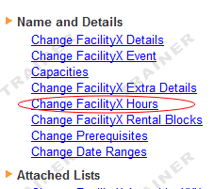**

**FACILITYOVERLAPS**

* Administration > Facility Settings 🡪 Facility Overlaps

**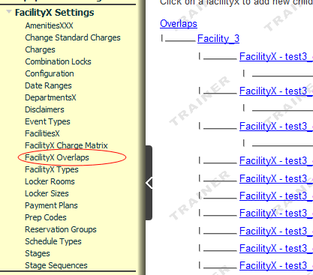**

**FACILITYOVERLAPROLLUP**

* This is blank table. I made some related operations, I did not find what operations can be associated with this table

**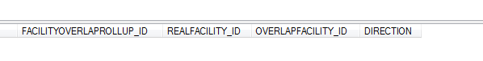**

**FACILITYTYPES**

* Administration > Facility Settings 🡪 Facility Types

**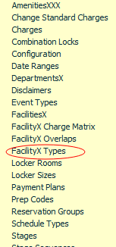**

**FAMILIES**

* Administration > Population Settings 🡪 Customers

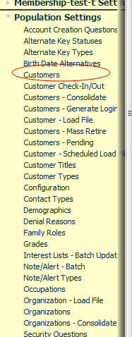

**FAMILYMEMBERS**

* Administration > Population Settings 🡪 Customers

**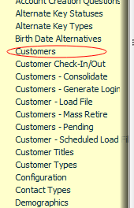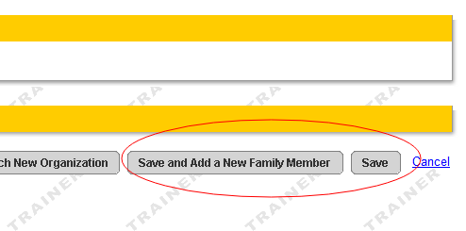**

**FAMILYROLES**

* Administration > Population Settings 🡪 Family Roles

**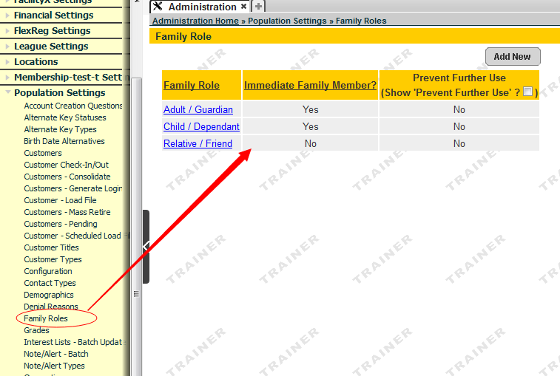**

**FEECONTRACTS**

* Administration > Web Admin 🡪 Fee Contracts

**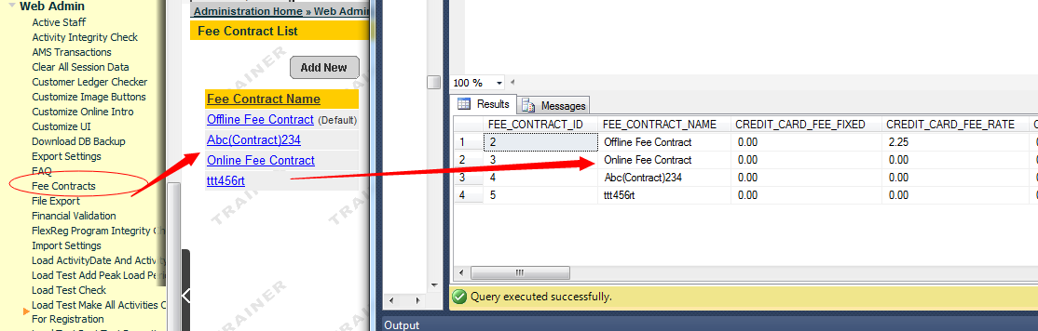**

**FEECONTRACT\_CUST\_TYPES**

* And the main foreign key link watch is “FEECONTRACTS” , They are relationship with the associated key is: “FEE\_CONTRACT\_ID”.

When you create “Fee Contracts” This table is accessed

**FEECONTRACT\_PACKAGES**

* The same as the above. And the main foreign key link watch is “FEECONTRACTS”, They are relationship with the associated key is: “FEE\_CONTRACT\_ID”.

When you create “Fee Contracts”. This table is accessed

**GEOGRAPHIC\_AREAS**

* Administration > Locations 🡪 Geographic Areas

**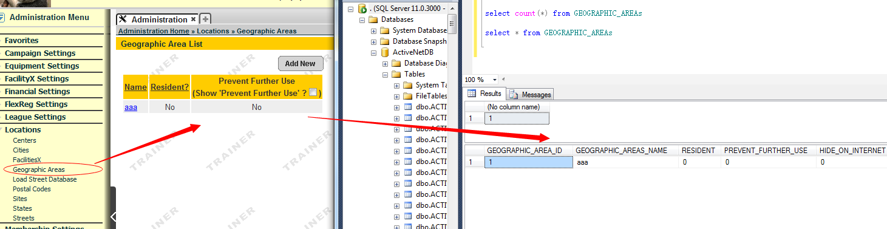**

**GRADES**

* Administration > Population Settings 🡪 Grades

**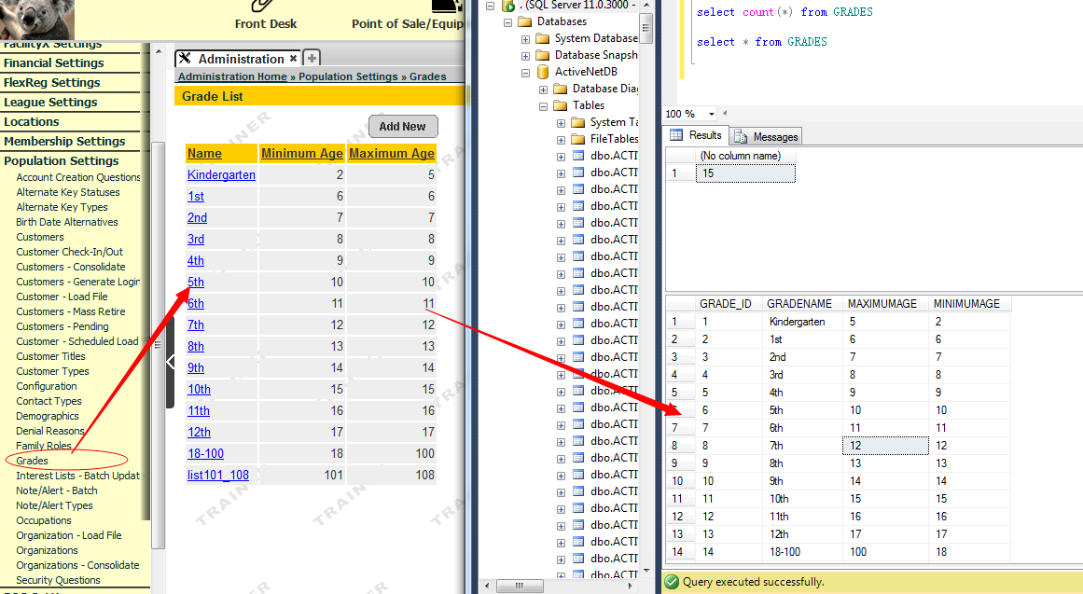**

**FACILITYOPENINGTIME**

* Administration > Facility Settings 🡪 Facilities 🡪 Hour of Availability (overriding center’s hours)

When add or update “Hour of Availability” from Facilities. This table is accessed.

**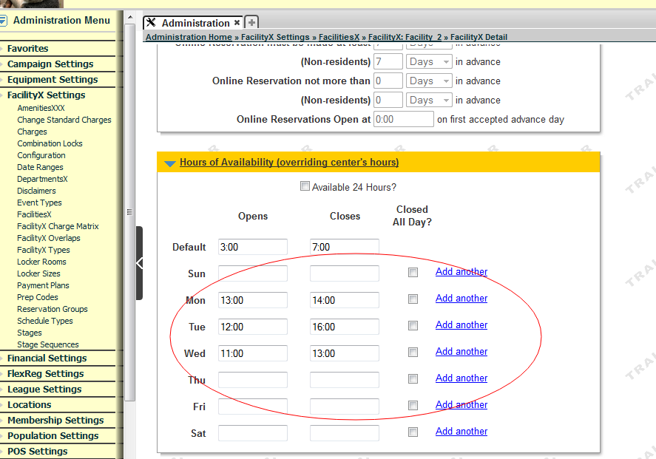**

**MEMBERSHIP\_PASSES**

* Front Desk > Membership 🡪 Sell Membership

When sell membership this table is accessed.

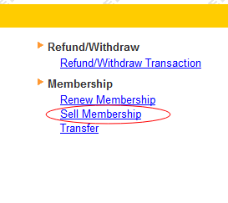

**FACILITYKEYWORDS**

* Administration > facilities 🡪Name and Details / Actions /Attached Lists

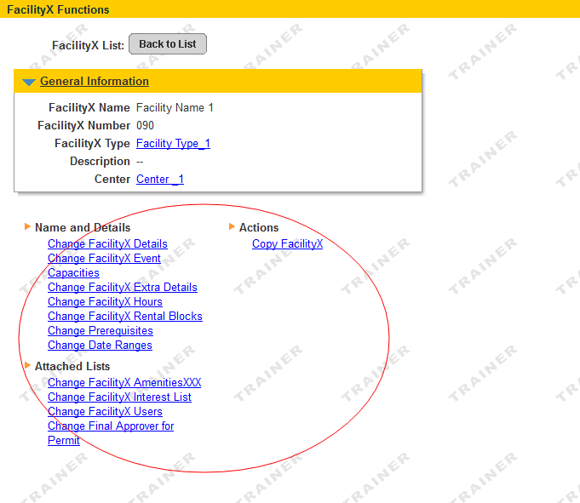

**KEYWORDS**

* Administration > Facility Settings 🡪 Amenities

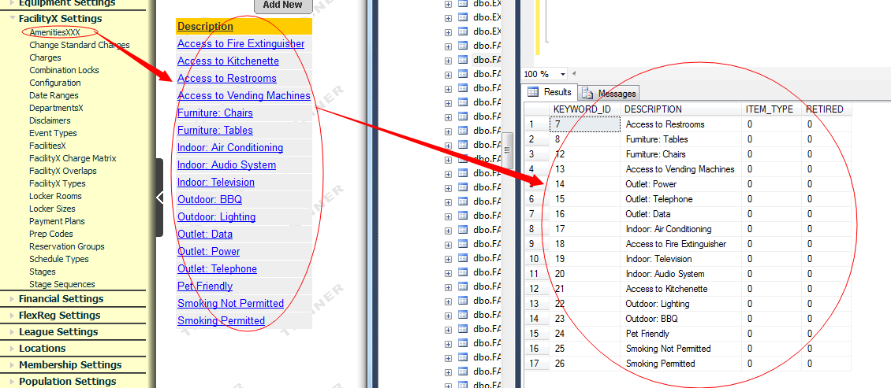

**KEYWORDSITES**

* Administration > Equipment Settings 🡪 Equipment Accessories

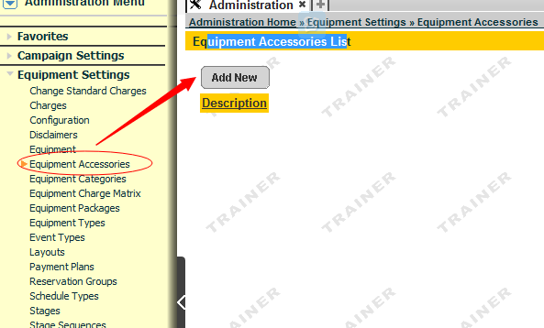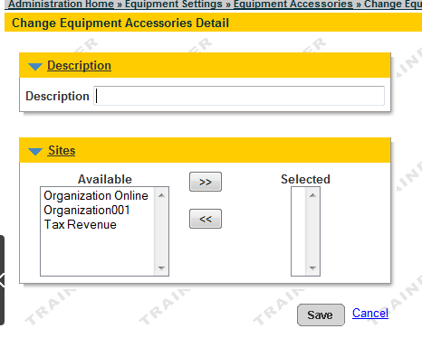

**MEMBERSHIP\_SINCE\_DATES**

* Front Desk Home > Membership > Inquiry > Membership Admin

**MEMBERSHIP\_USAGES**

* Front Desk Home > POS > Sell

**MEMBERSHIPS**

* 1.Open New Front Desk Home » Membership » Inquiry » Membership Admin  
  2.Open New Front Desk Home » Membership » Batch Suspend  
  3.Administration Home » Population Settings » Customers » Merge Two Customers  
  4.Administration Home » Membership Settings » Packages

**OCCUPATIONS**

* Administration > Population Setting > Occupations

**PACKAGE\_CATEGORIES**

* 1. Administration > Membership Setting > Packages Categories  
  2. Administration > Membership Setting > Packages > Modify > Click Category

**PACKAGE\_ENTRY\_POINTS**

* Administration > Membership Setting > Entry Points

**PACKAGE\_FEES**

* 1. Administration > Membership Setting > Packages - Change Fees  
  2. Administration > Membership Setting > Packages > Modify > Change Fees

**PACKAGES**

* Administration > Membership Setting > Packages

**PASSES**

* Open New Administration Home » Membership Settings » Pass Layouts

**PERMITCHANGES**

* 1. Front Desk Menu > Reserve > Permits > Reservation Details > Change Place / Date / Time  
  2. Front Desk Menu > Reserve > Permits > Reservation Details > Change Customer / Organization / Permit Administrator  
  3. Front Desk Menu > Reserve > Permits > Permit Status > Change the Notes / Disclaimers  
  4. Front Desk Menu > Reserve > Permits > Permit Status > Change Status / Checklist / Stages  
  5. Front Desk Menu > Reserve > Permits > Permit Status > Cancel Permit  
  6. Front Desk Menu > Reserve > Permits > Permit Status > Complete Permit

**PERMITS**

* 1. Front Desk > Reserve > Quick Reserve  
  2. Front Desk > Reserve > Reserve Facility  
  3. Front Desk > Reserve > Reserve Equipment  
  4. Front Desk > Reserve > Reserve Instructor  
  5. Front Desk Menu > Reserve > Permits > Reservation Details > Change Place / Date / Time  
  6. Front Desk Menu > Reserve > Permits > Reservation Details > Change Customer / Organization / Permit Administrator  
  7. Front Desk Menu > Reserve > Permits > Permit Status > Change Status / Checklist / Stages  
  8. Front Desk Menu > Reserve > Permits > Permit Status > Cancel Permit  
  9. Front Desk Menu > Reserve > Permits > Permit Status > Complete Permit

**POSGROUPS**

* Administration > POS Setting > Layouts

**POSPRODUCTFEES**

* Administration > POS Setting > Product > Add New/Change POS Product Details

**POSPRODUCTLOGS**

* ChangeLogQManager

**POSPRODUCTS**

* Administration > POS Setting > Product

**PRODUCTCLASSES**

* Administration > POS Setting > Product Classes

**PRODUCTDEPARTMENTS**

* Administration > POS Setting > Product Departments

**PRODUCTLINKS**

* Administration > POS Setting > Product > Change Linking Products

**PRODUCTSUBCLASSES**

* Administration > POS Setting > Product Sub-Classes

**PROFILEOPTIONS**

* Administration > System Setting > System User Profile > Function and Report Authorities

**PROFILES**

* Administration > System Setting > System User Profile

**REASONS**

* Administration > System Setting > Reasons

**RECEIPTDETAILPAYMENTS**

* 1. Open New Reports Home » Financial Reports »  
  2. Pending Receipt #2 » Registration » Enroll

**RECEIPTDETAILS**

* Pending Receipt for Drop-In Customer » Receipt Payment
* Pending Receipt #1 » Refund/Withdraw » Find Transaction
* See RECEIPTHEADERS

**RECEIPTHEADERS**

* Pending Receipt for Drop-In Customer » Receipt Payment
* Pending Receipt #1 » Refund/Withdraw » Find Transaction
* When making a payment, which is associated with several tables will be modified.

**RECEIPTPAYMENTS**

* Pending Receipt for Drop-In Customer » Receipt Payment
* Pending Receipt #1 » Refund/Withdraw » Find Transaction
* See RECEIPTHEADERS

**RG\_CATEGORY**

* Administration Home » Registration Settings » Activity CategoriesX

**RG\_SUB\_CATEGORY**

* Administration Home » Registration Settings » Activity Sub-CategoriesX

**SEASONS**

* Administration Home » Registration Settings » Seasons / Terms

**SITEINFO**

* Administration Home » Locations » Sites (Add New will insert some default value)
* Administration Home » Locations » Sites » Change Site ( insert, update )

**SITES**

* Administration Home » Locations » Sites

**STANDARDCHARGES**

* Administration Home » Facility Settings » Facility Charge Matrix
* Administration Home » Facility Settings » Change Standard Charges
* Administration Home » Equipment Settings » Equipment Charge
* Administration Home » Equipment Settings » Change Standard Charges

**SYSTEM**

* Administration Home » Web Admin » Site Licensing

**SYSTEM\_USERS**

* Administration Home » System Settings » System Users

**SYSTEMINFO**

* Administration Home » System Settings » Configuration – Wording
* Administration Home » System Settings » Configuration – General
* The two pages have been confirmed to be able to modify table.

**SYSTEMUSAGELOG**

* This table records the information of login.

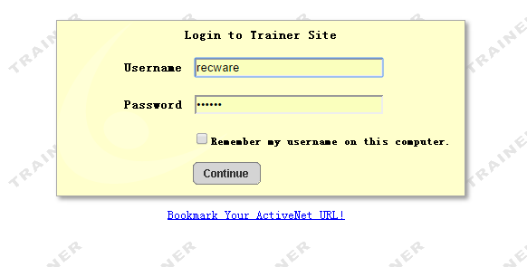

**SYSTEMUSER\_PROFILES**

* Administration Home » System Settings » System Users » Change System User

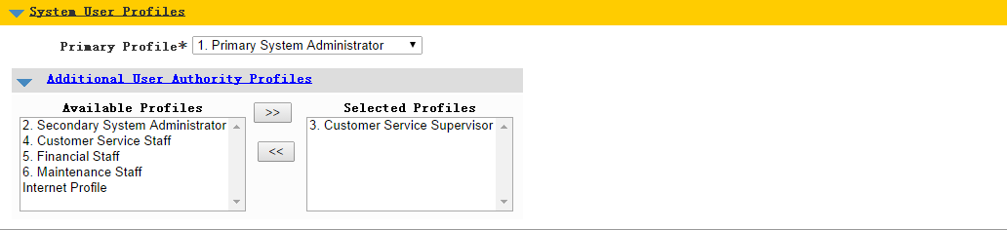

**TEAMS and** **TEAMCONTACTS**

* Step 1
* Administration Home » Registration Settings » Activities » Activity: Test – 121
* Administration Home » Registration Settings » Activities - Modify Dates » Activity: Test -- 121
* 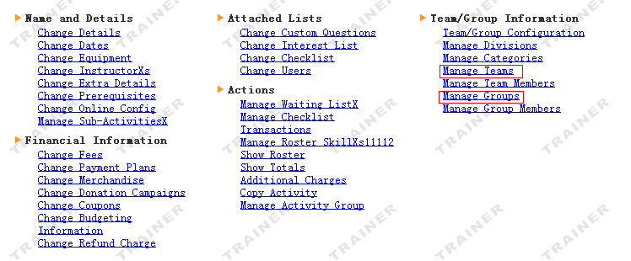
* Step 2
* 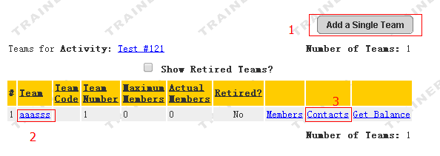
* NO. 1 insert TEAMS.
* NO.2 update TEAMS.
* NO.3 insert and update TEAMCONTACTS.
* Step 3
* 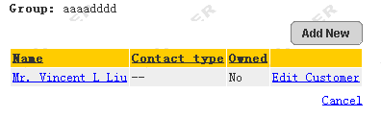
* pay attention to: TEAMS and TEAMCONTACTS is used for [Leagues](http://localhost:8080/ActiveNetServlet/admin.sdi?oc=League&use_search_pattern=true).
* [Administration Home](http://localhost:8080/ActiveNetServlet/homepage.sdi?topmost_menu_id=tab_admin) » League Settings » [Leagues](http://localhost:8080/ActiveNetServlet/admin.sdi?oc=League&use_search_pattern=true" \t "sdi_main) » [League: League\_Match Ranking Points](http://localhost:8080/ActiveNetServlet/adminChange.sdi?oc=League&league_id=1) » Team List
* 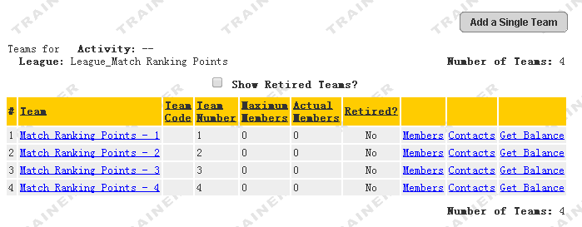

**TRANSACTION\_TYPES**

* It maybe can’t modify.

**TRANSACTION****COUPONS**

* Administration Home » Financial Settings » Coupons

**TRANSACTIONS**

* Pending Receipt for Drop-In Customer » Receipt Payment
* Pending Receipt #1 » Refund/Withdraw » Find Transaction
* See RECEIPTHEADERS

**WORKSTATIONS**

* Administration Home » System Settings » Workstations